**Frontend Development with React.js**

**Project Documentation**

**1.Introduction**

**Project Title:**

**Cook Book :** Your Virtual Kitchen Assistant

**Team Members:**

M.Gopika

M.Agalya

E.Kavitha

M.Mahalakshmi

**2.Project Overview**

* **Project Name :Cook Book**
* **Project Type :Cooking Platform**

**Introduction:**

"Your Virtual Kitchen Assistant" — a revolutionary cookbook designed to empower both novice cooks and seasoned chefs to master the art of cooking with ease, creativity, and confidence. Whether you’re preparing a quick weekday meal, exploring a new cuisine, or experimenting with innovative techniques, this cookbook is your go-to guide to unlock the full potential of your kitchen

In today’s fast-paced world, the kitchen should be a place of inspiration, not stress. This cookbook combines the convenience of modern technology with the timeless joy of cooking. With a focus on making cooking accessible, intuitive, and enjoyable, it takes on the role of your personal virtual kitchen assistant. Imagine having a trusted guide at your side, offering suggestions, simplifying recipes, and helping you through every step of meal prep, from the simplest dinner to an elaborate feast.

**Project Overview:**

"Your Virtual Kitchen Assistant" is an innovative cookbook designed to revolutionize your cooking experience by integrating modern technology with traditional culinary arts. Aimed at both novice and seasoned cooks, this cookbook serves as a personal guide, offering tailored recipes, smart kitchen tips, and meal-planning strategies to enhance your culinary journey.

**Key Features:**

* Personalized Recipe Selection: Utilize interactive features to receive recipe recommendations based on your dietary preferences, available ingredients, and cooking skills.
* Step-by-Step Guidance: Each recipe is accompanied by clear, concise instructions, supported by images and videos accessible via QR codes, ensuring a seamless cooking process.
* Smart Meal Planning: Plan your weekly meals efficiently with customizable templates and shopping lists, optimizing your time and resources.
* Ingredient Substitution Guide: Access a comprehensive list of ingredient substitutions to accommodate dietary restrictions and unexpected pantry shortages.

**3.Architecture**

**Component Structure**

**1.Navigation Components:**

Implement a bottom navigation bar with clearly labeled icons to facilitate easy access to primary sections such as Home, Recipes, Meal Planner, and Settings.

**Recipe Display Components:**

Design cards or list items to showcase recipes with essential details like title, image, and brief description.

**Interactive Elements:**

Include buttons, sliders, and toggles for user interactions, ensuring they are appropriately sized for one-handed use, considering that approximately 85% of mobile users operate their devices with one hand.

**2. Business Logic Components**

**Recipe Management Module:**

Handle operations related to adding, editing, deleting, and categorizing recipes.

**Meal Planning Engine:**

Generate personalized meal plans based on user preferences, dietary restrictions, and available ingredients.

**Shopping List Generator:**

Create shopping lists derived from meal plans, allowing users to check off items as they shop.

**3. Data Management Components**

**User Profile Manager:** Manage user data, including preferences, dietary restrictions, and cooking history.

**Recipe Database Interface:** Handle data retrieval and storage operations from the local or cloud-based recipe database.

**Synchronization Service:** Ensure data consistency across devices by managing data synchronization processes.

**4. Integration Components**

**Voice Assistant Integration:** Enable voice-activated commands and queries by integrating with platforms like Amazon ,Alexa or Google Assistant.

**Smart Device Connectivity:** Allow the app to communicate with smart kitchen devices, such as ovens and refrigerators, to provide real-time assistance.

**Notification Service:** Manage push notifications for reminders, new recipe suggestions, and app updates.

**State Management Strategies:**

Choosing the appropriate state management approach depends on the application's complexity and the platforms it supports.

Common strategies include:

**Local State:** Managed within individual components, suitable for simple applications with minimal data sharing requirements.

**Global State:** Utilizes centralized stores accessible across various components, beneficial for applications with shared data needs.

**Server State:** Involves synchronizing application state with server data, essential for applications that rely on external data sources.

**URL State:** Manages state through URL parameters, useful for applications requiring bookmarking or deep linking features.

**Benefits of Effective State Management:**

**Consistency:** Ensures uniformity of data across the application, preventing discrepancies between UI and underlying data.

**Performance:** Optimizes rendering processes by efficiently updating only the components affected by state changes.

**Scalability:** Facilitates the addition of new features without disrupting existing functionalities, as state management provides a clear structure for data flow.

**Routing:**

**Description:** The main entry point for the app. It could feature a search bar, daily recipe suggestions, and quick links to key features

(e.g., meal plans, shopping lists, and favorite recipes).

**1. Recipe Search Page**

Route: /search

**Description:** Allows users to search for recipes based on ingredients, meal types, dietary preferences, etc.

Sub-routes:

/search/vegetarian

/search/dairy-free

/search/quick-meals

**2. Recipe Details Page**

Route: /recipe/:id

**Description:** Displays detailed information about a recipe, including ingredients, instructions, and nutritional facts.

**4.Setup Instructions**

**Prerequisites:**

Project Planning & Requirements Gathering

Understanding the User Needs: Before jumping into coding, it’s essential to understand who your users are and what they expect from the app. Some questions to consider:

What features are essential (e.g., recipe search, meal planning, shopping lists)?

**1. Frontend Development:**

HTML, CSS, and JavaScript: For web development, a basic understanding of HTML, CSS, and JavaScript is essential to structure the user interface and add interactivity.

**Frontend Framework/Library:**

React (for Web): If you're developing a web app, React is one of the most popular JavaScript libraries to handle the frontend. You'll need to know how to create components, manage state, and work with routing (using React Router).

**2. Backend Development (API & Database)**

Backend Framework: You’ll need a backend to manage data like recipes, user preferences, shopping lists, etc.

Node.js with Express: One of the most popular choices for building backend APIs. Express helps manage HTTP requests and create RESTful API routes.

**Auth Libraries:**

Passport.js (for Node.js)

Firebase Authentication (for easier, out-of-the-box authentication)

User Profile Management: Allow users to register, log in, and manage their profiles. This is where preferences, saved recipes, and meal plans come into play.

**5.Folder structure**

**Client:**

**1. Frontend Framework/Library:**

To make development faster and more efficient, you'll likely want to use a frontend framework or library. Here are some options:

**React.js (Web):**

* The most popular JavaScript library for building user interfaces.
* Allows you to create reusable UI components and manage the state of the application.

Use React Router for handling routing between different pages or views (e.g., home, recipe search, meal planning, etc.).

**React Native (Mobile):**

* If you're building a mobile app, React Native lets you use React to create native mobile applications for both iOS and Android with a single codebase.
* If you prefer, you can use Vue or Angular for the frontend. Both are robust and capable, though React tends to be the most popular choice for many projects.

**Utilities:**

**1. Smart Appliances:**

Smart Ovens & Cooktops: Control via apps or voice commands for hands-free cooking.

**2. Recipe & Meal Planning Apps:**

**Recipe Assistants:** Use AI to find recipes based on available ingredients and dietary needs**.**

**Voice-Activated Assistants:** Ask for recipe suggestions or set timers with simple voice commands.

**3. Grocery Shopping & Delivery:**

**Automated Shopping Lists:** Generate lists based on your meal plan and get groceries delivered.

**Pantry Tracking:** Keep tabs on your inventory to reduce food waste and plan meals efficiently.

**6.Component Documentation**

**Key Components:**

**HTML (Hypertext Markup Language):**

The backbone of web content, providing the structure and layout of a webpage through elements like headings, paragraphs, links, and forms.

**CSS (Cascading Style Sheets):**

Defines the visual appearance of web content. It handles the design, layout, and responsiveness of the page, including color schemes, fonts, and positioning.

**JavaScript:**

Adds interactivity and dynamic behavior to websites. It enables features like dropdowns, form validation, image sliders, and real-time updates without reloading the page.

**Frontend Frameworks/Libraries:**

**React, Angular, Vue:** These provide reusable components, state management, and efficient DOM rendering for building complex UIs.

**J Query (legacy**): A library that simplifies DOM manipulation and event handling**.**

**Reusable Components:**

Reusable components are modular, self-contained units of code that can be used across multiple parts of a website or web application without needing to be rewritten. These components improve code efficiency and maintainability.

**Key Benefits:**

**Code Efficiency:**

By reusing the same component, developers don’t need to rewrite code for similar features, saving time and reducing errors**.**

**Consistency:**

Reusable components ensure uniformity across the app (e.g., a button, card, or modal will look and behave the same everywhere).

**7.State Management**

**Global State:**

Global state refers to data that is shared and accessible across different components or parts of a web application. This allows components to communicate with each other and stay synchronized, especially in larger apps.

**Consistency Across Components:**

Global state ensures that different parts of an app have access to the same data without having to pass it through multiple layers of components.

**Simplifies Data Management**

Instead of passing props down through many levels of components, global state allows a central location for managing and updating the state.

**Local State:**

Local state refers to data that is managed within a single component and is only accessible to that specific component or its child components. It is often used for temporary or UI-specific data**.**

**Component-Specific Data:**

Local state is ideal for managing data that only needs to be used within a single component, such as form inputs, toggles, or modal visibility.

**8.User Interface**

User Interface (UI) refers to the visual elements and interactive components that allow users to interact with a software application or website. It includes everything a user experiences on the screen, such buttons, menus, icons, forms, and layouts.

**Key Aspects of UI:**

**Layout:**

Organizes elements on the screen to make the content visually appealing and easy to navigate (e.g., grid systems, spacing).

**Design Elements:**

**Typography:**

Fonts and text styles to improve readability.

**Colors:**

A color scheme that matches the brand and improves user experience.

**Icons & Buttons:**

Graphical elements that indicate actions or features.

**Interactivity:**

The components that allow users to interact with the application, such as clickable buttons, sliders, input fields, and modals.

**9.Styling**

**CSS Framework/Libraries:**

CSS frameworks and libraries are pre-written collections of CSS code that help developers create consistent, responsive, and attractive designs more quickly. They offer ready-to-use styles, components, and layout systems, reducing the need to write custom CSS from scratch**.**

**Key Benefits:**

**Faster Development:**

Predefined styles and components speed up the development process, saving time on writing repetitive CSS.

**Consistency:**

Frameworks provide a consistent design system, ensuring that styles are uniform across the website or app.

**Theming:**

**Branding:**

Theming ensures consistency with a brand’s identity by applying specific colors, fonts, and styles.

**User Customization:**

Some applications allow users to choose from different themes (e.g., dark mode vs. light mode) to enhance their personal experience.

**10.Testing**

**Testing Strategy:**

A testing strategy defines the approach, types of tests, and tools used to ensure that a frontend application works as expected. It helps catch bugs early, improve code quality, and ensure a smooth user experience.

**Key Types of Tests:**

**Unit Testing:**

Focuses on testing individual functions, methods, or components in isolation. It ensures that each unit of the code performs as expected.

**Tools:** Jest, Mocha, Jasmine.

**Integration Testing:**

Tests how different parts of the application (e.g., components, services, APIs) work together. It ensures that the integration between various modules functions correctly.

**Tools:** React Testing Library, Enzyme, Cypress.

**11.Screenshot or Demo**

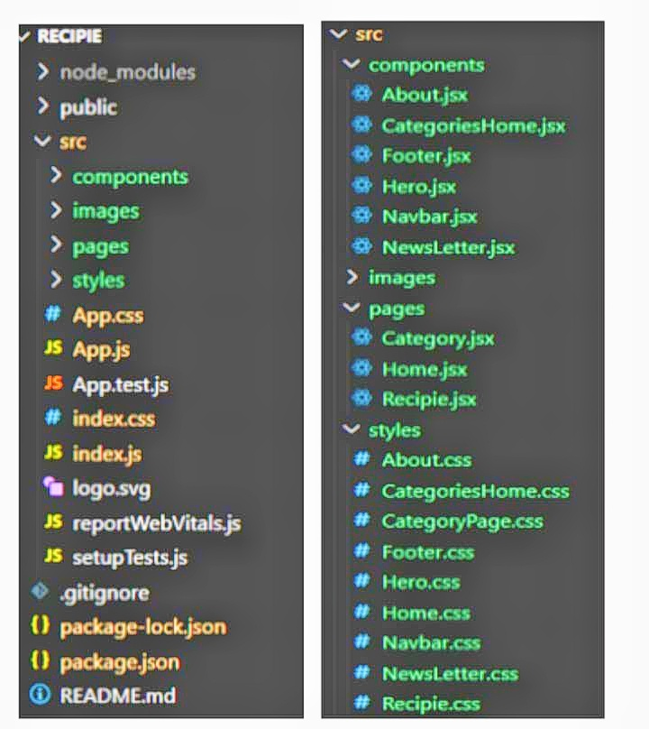

**12.Known Issues**

Known issues refer to problems or bugs that are already identified in a project, whether within the codebase, libraries, or frameworks, and are either pending resolution or require workarounds. These issues might affect functionality, performance, or user experience but have not been fully fixed yet.

**Common Known Issues in Frontend Development:**

**Cross-Browser Compatibility:**

Web apps often look and behave differently across browsers (Chrome, Firefox, Safari, etc.), especially with newer CSS/JavaScript features

**Workaround:** Use polyfills, CSS resets, and testing tools like BrowserStack to ensure compatibility.

**Performance Bottlenecks:**

Large JavaScript bundles, excessive DOM manipulation, or unoptimized images can slow down page load times, especially on mobile devices.

**Workaround:** Implement lazy loading, code splitting, and image optimization techniques.

**13.Future Enhancements**

Future enhancements refer to emerging technologies, tools, and methodologies that aim to improve frontend development, making it faster, more efficient, and more user-friendly. These advancements shape how developers create applications, focusing on performance, scalability, and user experience.

**Key Areas for Future Enhancements:**

**WebAssembly (Wasm):**

Allows developers to run high-performance code (e.g., C, C++) in the browser, significantly improving speed and enabling complex computations in web apps.

**Impact**: Faster, more powerful web apps for gaming, simulations, and other performance-critical applications.

**Server-Side Rendering (SSR) & Static Site Generation (SSG):**

With frameworks like Next.js, developers can render pages on the server before sending them to the client, improving SEO and performance.

**Impact:** Faster page loads, better SEO, and enhanced user experience for dynamic and content-heavy websites.